Banking Resolution of Corporation

I, Marci Campbell, Secretary of National Certified Public Manager® Consortium, referred to as corporation, certifies that the following is a true copy of resolutions adopted by the Board of Directors of this corporation at a meeting held on proper notice, a quorum being present, on November 4, 2021, and that such resolutions are now in full force and effect.

Resolved that the Wells Fargo Bank N.A. is designated a depository of this corporation; and

Further resolved, that effective November 5, 2021 for all drafts, checks, and other instruments or orders for the payment of money drawn against the account or accounts of this corporation with such depository shall be signed by any one (1) of the following:

Randy W. Harrison
Patricia E. Morgan

Further resolved, that such depository is authorized to place to the credit of the account, or any of the accounts of this corporation, funds, drafts, checks, bills of exchange, or other property whomever delivered to such depository for deposit for account of this corporation, endorsed with the name of this corporation by rubber stamp, facsimile, mechanical, manual or other signature (and any such endorsement by whomever affixed shall be the endorsement of this corporation), or otherwise endorsed, or unendorsed, provided that if any such draft, check or other property shall bear, or be accompanied by, directions (by whomever made) for deposit to a specific account then such deposit shall be to the credit of such specific account; and

Further resolved, that such depository is directed to accept, and/or pay and/or apply any draft, check, instrument or order for the payment of money, or any proceeds thereof, drawn on such account or accounts when signed as required by these resolutions without limits as to amount, without inquiry, and without regard to the disposition of any such item or proceeds thereof, and such depository shall not be liable in connect therewith notwithstanding that such item may be payable to the order of a person whose signature appears thereon or of any other officer or officers, agent or agents of this corporation, or such item or any proceeds thereof may be used for the personal credit or account of any such person or person with the depository or used in payment of the individual obligation of any such person or persons to the depository or otherwise.

Further resolved, that such depository is authorized to deduct from the accounts of the corporation the regular promulgated service charges and fees for accounts and other services rendered to the corporation.

Dated: November 4, 2021
National Certified Public Manager Consortium

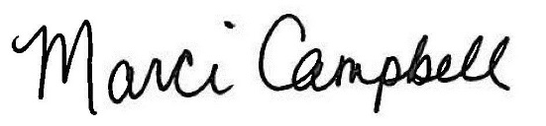

by its Secretary
Dr. Marci Campbell

