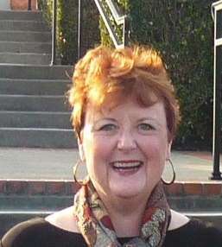

*Insert list of volunteer involvement and associated years here.*

*Nominating Committee Chair 2014*

*Legacy Task Force 2016, 2017*

2012

2013

Chair

Kathleen Parker

North Carolina