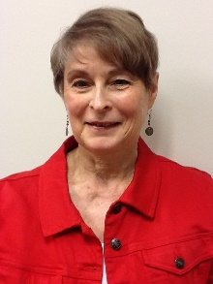

*Insert list of volunteer involvement and associated years here.*

*Nominating Committee Chair 2016*

*Legacy Task Force 2016, 2017*

2014

2015

Chair

Mary Hamilton

Nebraska