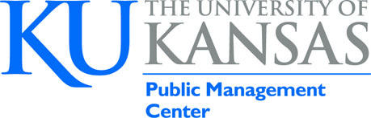

CPM Consortium Chair and CPM Administrator
Cheryl Robertson

October 15, 2018

Dear Cheryl,

The University of Kansas, School of Public Affairs and Administration, Public Management Center formally requests to have the Kansas Certified Public Manager ®program reviewed for reaccreditation in 2019.

We look forward to the process of review and hearing recommendations of how to continually improve the Kansas program. We appreciate the time and commitment of the committee members to review our program and make a site visit. This is an invaluable process of sharing best practices.

Thank you!

Sincerely,

Terri Callahan, Director, Kansas Certified Public Manager Program
tcallahan@ku.edu
University of Kansas Public Management Center

