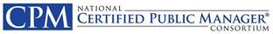
The Organization’s Accomplishments
From the Chair
• • •

A Year in the Story of NCPMC
Howard Balanoff, Chair | 2002/2003 | Jack Lemon, Administrator

  - Key Initiatives in 2002/2003
Howard’s comments

General Board Business

  - Registered CPM Trademark
- Engaged Attorney to file trademark paperwork

  - Hosted Consortium and CPM Website on Texas State Webpage for 13 years
Photo of Board

NCPMC
2003 Annual Meeting
Location

