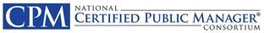
The Organization’s Accomplishments
A Year in the Story of NCPMC
Mary DeLorenzo, Chair | 2015/2016 | Peggy Stewart, Administrator

From the Chair
• • •
I was honored and humbled to serve as Chair for the year 2015/2016. My theme for the year was:
Honoring the Past while Preparing for the Future
We focused on strengthening the viability of NCPMC through sound governance, strong branding, fiscal accountability, and collaborative efforts that would hold meaning for our members and our graduates. We laid the groundwork for future business opportunities through which we may gain multiple streams of income, including strategic collaboration, expanded CPM branding outside the continental US, and an evolving annual meeting format to better serve members, graduates, and strategic partners.
I am very proud that we accomplished many items that were already in the works, initiated relevant new projects, and did our best to advance public service through CPM.
  - Key Initiatives in 2015/2016

General Board Business
New officer position transition
Ann Cotten, Treasurer
- E&O Insurance Coverage purchased for Board
- Conflict of Interest Form adopted by Board
- Engaged CPA for annual Corporate Tax Return
Approved conducting Midyear Meeting in electronic format
- Visioning Session moved to Annual Meeting
Approved conducting election in advance of Annual Meeting
- Passing of the Gavel Ceremony added
- Removed 30-day transition period after election
Approved Accreditation Team Evaluation Process
Approved Changes to Status
- Associate for Louisiana
- Active for Georgia, & Netherlands, extended for Massachusetts
- Initial Accreditation for Virginia & Georgia
- Continuing Accreditation for Arkansas, Indiana, South Carolina (AZ postponed)
- Withdrawal for Alaska, Michigan, Montana, Ohio (Alaska & Michigan to reapply for Associate)

Committees/Goal Teams
Governance
Ellen Freeman-Wakefield, Chair
Standards, SOP, & proposed changes
Marketing Committee
Kathleen Beaumont, Chair
- Consortium Website Design & Launch
- Developed & adopted logo, lapel pin, QR code, stamp for “Accredited by” & tagline “Connect. Engage. Lead.”

Task Force Work Completed
Administrator Search
Charles Taylor, Chair
- Contracted with Patty Morgan, Red Shoe, LLC
Accreditation Realignment Hector Zelaya, Chair
- 6 year cycle and fee structure adopted by Board
Strategic & Sustaining Partnerships
Jolie Busby, Chair
- Officers met regularly with AACPM officers
- Conducted Needs Assessment Survey of CPM graduates
2017 Annual Meeting Planning
JJ Acker, Chair
- Transitioning Annual
Meeting Format
NCPMC Legacy
Mary Hamilton and Susan Paddock, Co-chairs
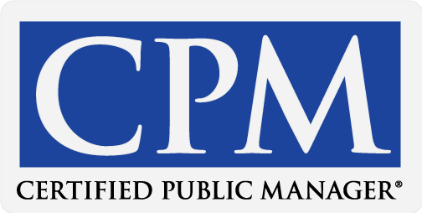
NCPMC Strategic Goals
- Accredit CPM programs that promote consistent high standards and facilitate innovative program development
- Build awareness and respect for the CPM credential through branding, marketing, and advocacy
- Advance CPM organizational sustainability by strengthening financial viability, operational infrastructure, and overall growth.

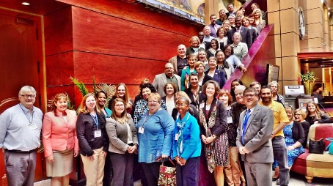
NCPMC
2016 Mid-year Meeting
Oklahoma City, OK

NCPMC
2016 Annual Meeting
Baltimore, Maryland

