September 21, 2022

Dear CPM,

The Certified Public Manager® Educational Foundation (CPMEF) has established and administers the Jack Lemons Student Scholarship and is seeking to identify worthy recipient(s) for 2022. The Jack Lemons Scholarship is based on need to fund registration and or travel expenses and can range from $100 to $500 per recipient.

CPMEF established this scholarship program to serve the needs of CPM students currently enrolled in a CPM program, and CPM graduates seeking to attend continuing education from sponsored by a CPM program who are not receiving agency support. The Scholarship is named after Jack Lemons who was and instructor and administrator of the North Carolina CPM program, one of the seven founding State Societies of AACPM. Jack went on to become the administrator of the CPM Consortium for many years and supported the growth of the national program to over 35 participating states. The Foundation celebrates this legacy to North Carolina and the nation by providing awards annually to deserving students who plan a career in public service.

Attached is an application form with instruction for applicants. The completed application must be submitted no later than October 31, 2022

If you have questions, please contact myself, or any other member of the CPMEF board.
Sincerely,
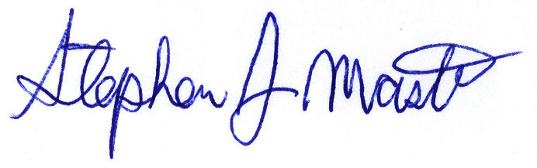
Stephen J. Mastro

Evaluation Criteria:

The following criteria shall be used for scoring applications for the Jack Lemons Scholarship:

- Scholarship 7 points possible:
  - Working full time while enrolled 1-2 point
  - Completed one or more courses in program 1-3 points
  - Relevance of course/program to CPM Training 1-2 points
- Financial Need 10 points possible:
  - Level of agency financial support. 1-6 points
  - Level of ability for family contribution 1-4 points
- Community Service/Leadership 6 points possible:
  - Low to moderate involvement. 1-3 points
  - High involvement, including leadership role(s) 0-3 points
- Recommendations 5 points possible:
- Recommendation from supervisor or manager 1 points
- Indicates education will benefit employee 1 point
- Indicates education will benefit organization 1 point
- Indicates commitment to public service 1 point
- Indicates leadership qualities of applicant 1 point
- Quality of application 2 points possible:
  - Application information is clear and concise 0-1 points
  - Application is professional and complete. 0-1 points

Note: Please prepare your application responding to each of the criteria areas listed above.

