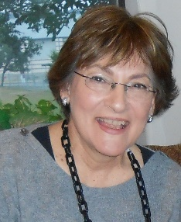

*Fill in volunteer involvement and years as such here*

*Legacy Task Force 2016, 2017*

2011

2012

Chair

Marilyn Balanoff

Texas